| **Test Name** | | Update Worker details in Database | | | |
| --- | --- | --- | --- | --- | --- |
| **Use Case Tested:** | | Use Case 9 – Manage Worker | | | |
| **Test Description:** | | User needs to amend the details for a worker  User navigates to Search Workers tab  User is presented with a list of workers  User searches for the required worker  User amends the information  User submits form | | | |
| **Pre-conditions** | | Worker must exist in the system | | | |
| **Post-conditions** | | The database is successfully updated with the new data for the Worker. | | | |
| **Notes:** | | **Worker ID field should be read only when worker details are to be updated.** | | | |
| **Result (Pass/Fail/Warning/Incomplete)** | |  | | | |
|  | **TEST STEP** | | **EXPECTED TEST RESULTS** | P | F |
|  | User selects “Search Workers” from the menu bar | | A list of workers appears | X |  |
|  | User searches for the required worker | | A list of workers matching criteria appears | X |  |
|  | User selects required worker | | Worker details is uploaded into the Worker Details form | X |  |
|  | User unable change Worker Id | | Unable to as field is read only | X |  |
|  | User amends other details as necessary | | Input does not show error | X |  |
|  | User selects Submit button | | Message appears that the record was successfully updated | X |  |
|  |  | | Database updated to show new details for worker | X |  |

|  |  |  |  |  |  |
| --- | --- | --- | --- | --- | --- |
| **Test Data Table** | | | | | |
|  | **1** | **2** | **3** | **4** | **5** |
| Test – 2 (current) | 1234 | Patrick | Smith | Pharmacist | False |
| Test – 2 (amended to) | 1234 | Patricia | Smyth | Locum Pharmacist | True |
|  |  |  |  |  |  |
|  |  |  |  |  |  |

**Test 2**

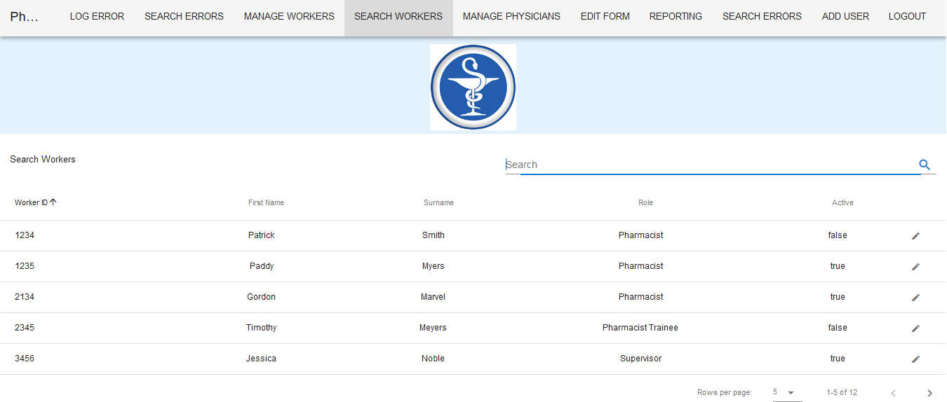

List of workers appears on selection of Search Workers tab.

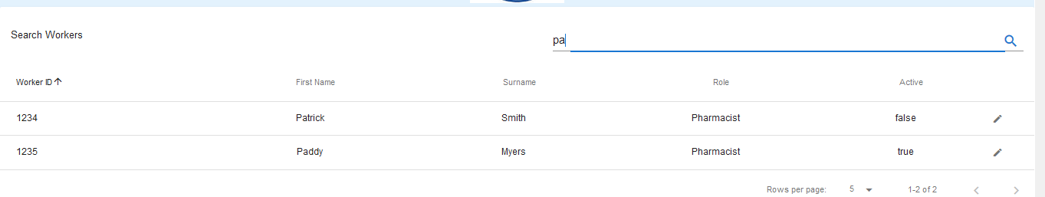

Search criteria returns two records.

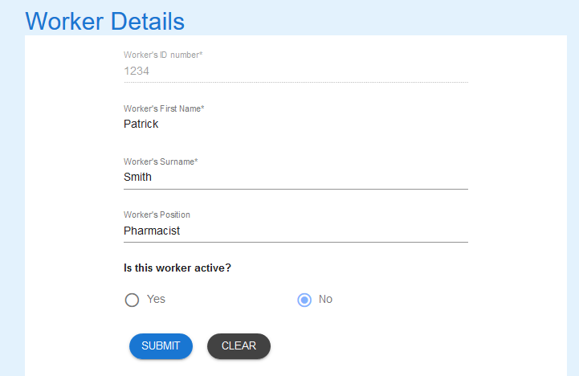

The record appears in the Workers Detail form – Worker’s ID number is read only

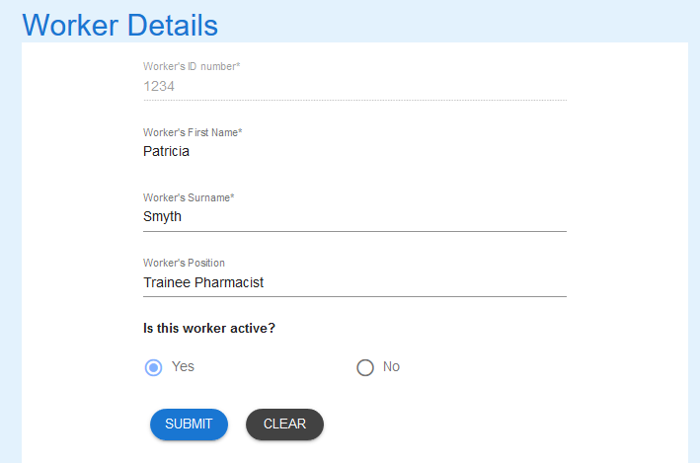

Updated details



Message returned

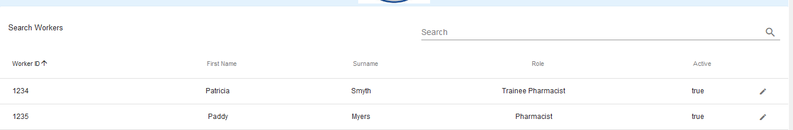

Record updated.